**M.Sc Thesis Synopsis**

**Robotic Reconstruction of Islamic Calligraphy**

Submitted by: Muhammad Umar Hasan (umar.techboy@gmail.com)

Registration No: 2017-MS-MC-17

Registration Date: 22-January-2020

Supervisor: Dr. Ali Raza

Email: umar.techboy@gmail.com



**DEPARTMENT OF MECHATRONICS AND CONTROL ENGINEERING**

University of Engineering and Technology Lahore.

May 2020.

# Abstract

Islamic calligraphy is also one of the many arts that has seen a downfall since the modern age. Especially with the transfer of printed media to digital form, the very activity of drawing and writing has been replaced by typing and digital graphics. This research will focus on proposing robotic/mechanized ways to uplift the repair and rehabilitation work of Islamic calligraphy alone. This is different than usual surface printing; revamping Islamic calligraphy not only means drawing on irregular surfaces of ancient sites, but also reproducing the exact tool movement a real artist would have made. The later concern is more important as this will keep the artistic sense intact. In this pursuit, firstly, the existing digital forms of calligraphy will be studied keeping in view the final target of reproducing it robotically/mechanically. Most of the existing work either exists only in hard form or images and glyphs. This data cannot be directly used with mechanized drawing and robots. A technique will be developed to bridge this gap between art and mechanized/robotic calligraphy. Finally, a low-cost robotic arm will be produced to verify and improve the discovered outcomes of the research work. In contrast to the industrial robots, which are robust and built on top of patented technologies, the aim would be to provide an open source hardware that can be reconfigured, re-scaled and rebuilt in low budgets.

# Introduction

Islamic calligraphy is an art having a history that dates back to the seventh century [1, 2]. It has witnessed many evolutionary stages [2, 3] and has been used by artists speaking several different languages [4] and sharing uncommon biographies [5-8]. Unfortunately though, the industrial age and the advent of technology has not spared this beautiful art when it claims to provide better alternatives for almost everything related to human beings. Discovery of new facets of calligraphy aside, with the prevalence of modern technologies and resulting lack of expertise in this domain, the very existence of Islamic calligraphy now faces a serious threat. Public buildings and infrastructure that once used to be a showcase for the most laudable artists of the time have turned in-to museums; awaiting to be wiped away slowly with each round of the monsoon and every splash of the ocean’s waves. Potentially, we can use robotic dexterity to help us in this domain. Industrial robots have already been used outside the industry to do unorthodox tasks [9- 12] and they can surely uplift this art as well. At the very least, they can be employed in restoration and replication of existing calligraphy work [13]. In other words, they can be used as printers that give an extra hand to the calligraphy artists to open up a new dimension of the art that can not only revamp the existing calligraphy sites but also create new art.

# The Problem Statement

Mechanized/robotic drawing of the Islamic calligraphy scripts requires not just the ink-mark information but also the information about the tool movement [3]. Specially, using a flexible flat head brush instead of a solid round tip pen and all that to draw on un-even surfaces, makes the job extremely special indeed. A robot needs to take special care about the orientation and downwards force of the tool.

In this context, this research has two main parts. The first is to discover the solution to the stated problem, and the second to verify the solution found.

# Methodology

One potential way to solve the modeling issue of calligraphy involves using the existing digital calligraphy fonts. There are, however, two critical issues involved with this scheme; one is the need of an algorithm that will convert the font data to robot movement data and the other is the lack of a font variety. Additionally, working with fonts leaves a narrow space of modifying the scripts to look like artistic scriptures. This is the primary reason we must not use the existing digital fonts.

Keeping in mind the gaps left by the digital font, another solution to this problem is in the discovery of a new way to unify ink-mark information of digital Islamic script and tool movement performed by the artist. Making a mathematical model to learn the drawing tool information just from the printed text is quite a complex job. Instead, only if we could form a way an artist can give digital input, this problem can be overcome.

The newly formed techniques also need verification through thorough practical application. This is usually done on a simulated or a real robot. A graphical physics simulation system would also be needed to be developed.

The first task would be to study the existing digital forms of Islamic calligraphy which is mainly based on glyphs. Digital fonts carry the least information to reproduce the final ink-marks of the script. They don’t carry information about the movement of the tool in the hands of a real artist. A new way awaits discovery that can unify the ink-mark information with the artist’s tool information.

Then, a technique needs to be developed to digitally generate the calligraphy work in the new data format. It requires taking input from the artist and embedding in to the ink-mark data. One proposed way to do this would be the use of an accelerometer equipped drawing to produce calligraphy. Special care would have to be taken while selecting an orientation sensor. INL and DNL would need to be in a range such that the error produced isn’t observable by the naked eye. Another is to use image processing in controlled space coupling the accelerometer data with the tool position information. However, emphasize would be laid to discover a simpler, more accurate way of getting this data.

For the verification of the outcomes of the research work, a robot simulator would also be needed. Considering the requirements of project and a lack of such a fully integrated simulation environment, the project aims on producing an integrated simulator. Based on this simulation, and as a by-product of the research work, this project aims on providing blueprints of a scale-able and configure-able robot that can easily be manufactured and provides simple user interface to enable an artist to create calligraphy with minimal technical skills required. It will also provide the researchers and engineers with a working prototype to learn, teach and experiment.

The robot configuration in discussion can be seen in Figure 1. It contains six revolute joints sitting right on top of the previous one. This gives the robot the six minimum required degrees of freedom.

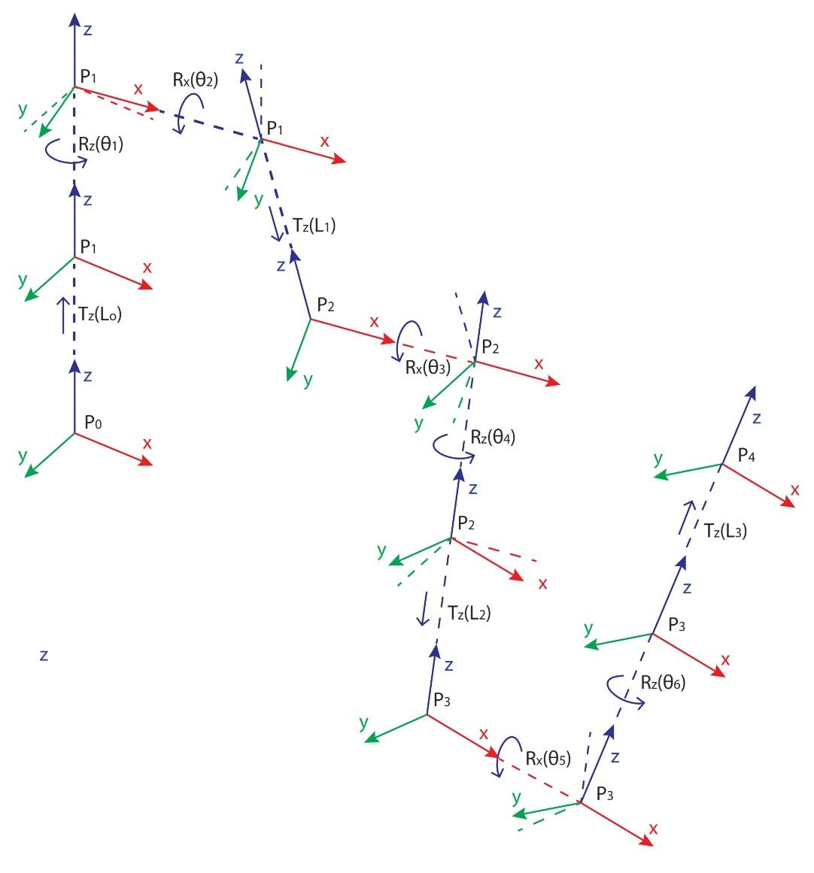

Some helpful work required for this project has already been introduced with the realization of Drogon 2.0 written completely by the author of this project. An open source application to simulate and analyses different facets of spherical arm robots. The application contains some bugs and shortcomings which need to be rectified first but it still is a potential tool to be used for this task. Here are some features that have been integrated in the existing application:

1. Two inverse kinematic solutions
2. A GUI representing the solved robot
3. Basic point to point movement animations
4. A rudimentary rotating Bezier spline editor

And some of these issues are listed here:

1. The inverse kinematics yield angles in the range of one rotation, however, it needs to go beyond that for the calligraphy work.
2. Simulator doesn’t have a very strong GUI
3. Most workspace analysis tools are missing
4. A fully equipped calligraphy editor is missing
5. The simulator needs to integrate with communication ports in order to communicate with the actual hardware (Only the protocol for the hardware will be developed).

To estimate the amount of work needed, it can be said that almost 20 percent of the work is already done on the simulator development. The rest constitutes the majority of the project work.

The other feature of Drogon 2.0 that acts as a basis for creating Islamic calligraphy is the rotating Bezier spline curve editor. It also needs some improvements but the fundamentals of the rotating Spline curve are going to remain as they are. The editor uses a modified Bezier spline curve instead of other polynomial fits because of its easy ability to decompose into smaller parts retaining the ability to perfectly join the terminals tangentially with each other.

Once the issues with Drogon 2.0 are resolved, the second step would be to use the tool to help identify the scale and sizes of the links and rotation limits in order to optimize the workspace. Although most of this exercise is highly programmatic and scientific, it still requires intuition and creative work since there is no hard rule to define a suitable relation between the links other than learning from iterative simulation.

Once a reasonable estimate about the link sizes and rotation ranges is made, the next step would be to identify the required torque on each link. This also requires finalizing mechanical structure so that the load of the body on the motors can also be accounted for. Once again, this step requires ingenious decisions since there is not a very wide range of motors available in the market and it is desired to design the robot to require as minimum a torque amount on each joint as possible. One of the possible solutions is to mechanically rid the actuators of lifting the load of the other motors. This can be done by moving most of the motors below the first actuator and transferring the torque to the respective joint by timing pulleys, torque rods and clutch cables. In pneumatics, this is analogous to having the main compressor sitting on the base while transferring its power to the pneumatic actuators that sit on the robot links.

The next step, obviously, is motor procurement and mechanical fabrication and assembly. A lot of focus in this step would be put to avoid any imported components during this process which can claim a big chunk of the available funds.

Once the structure is assembled, some basic testing electro-mechanical testing and calibration would be performed without any electrical drives. This step is required to verify that the procured motors and fabricated joints conform to the design specifications. This would also give us more solid information on maximum power the motors drain after they have been put in the real assembly.

This would be followed by design and construction of the motor drive circuitry. This circuitry would be responsible to drive the motors based on position and velocity information feedback from the links. The motor drivers would be responsible to drive the motors in at-least the basic working modes, being, constant position and constant velocity.

As the last design step, the drive circuit will be integrated with Drogon 2.0 to provide a user interface for calligraphy.

Finally, an artist will create some calligraphy samples using the rotating Bezier spline curve editor and it will be demonstrated using the fabricated robot.

# Expected Outcomes

The project is multidisciplinary and demanding in terms of dedication, skills and understanding about computer science behind graphics and how an electromechanical system works. However, the outcomes are fitting with the work demand. The by-product robot, being open hardware, can open a new door for robot design in the university.

There is space for augmentation in this project. First, the robot itself can be rescaled; there are going to be a handful of parts which would need improvement; torque based feedback can be added; overall control can be improved and a lot more. The rotating Bezier spline editor can be equipped by artificially intelligent image processing to scan vector data of existing artwork, which, in its own, is a huge project.

# Benchmarking the Outcomes

To benchmark the outcomes of the proposed solution, which is the rotating bezier spline curves, some valued parameters may be defined. It may be noted that some of these factors are qualitative and will be difficult to be quantized.

|  |  |  |  |  |
| --- | --- | --- | --- | --- |
| **Task** | **Measured Characteristic** | **Measurement** | **Result** | |
| **Ideal** | **Expected** |
| 1. Rotating Bezier spline curves | 1. How accurately can they be used to trace existing scripts? This can be measured by taking difference of the original specimens and the specimens traced using the rotating Bezier splines. | a. Percentage of area outside the original bounds | 0% | <5% |
| b. Percentage of area outside the original bounds | 0% | <5% |
| c. Maximum lateral deviation of the Bezier path from the pitch line | 0% | <5%  >-5% |
| 2. How well can it be used with different fonts? This can be done by testing the curves with several different types of scripts. The ones having more than 5% deviation of the coverage area will be considered not to be compatible with the curves | a. Total number of tested specimens |  | 10 |
| b. Total number of compatible scripts | All of them | 80% |
| c. Number of distinct characters in the test phrase. | Depends on the script |  |
| 3. How effective is the spline curves editor? This depends on a social experiment. At least three people from relative field will | a. Does it have a GUI? | Yes | Yes |
| b. What is the CPU and RAM usage? |  | <25% on atypical low end desktop computer |
| c. As compared to other vector editors, is it fairly easy to understand? | Yes | Yes |
| d. As compared to other vector editors, is it fairly easy to use? | Yes | Yes |
| e. Is the “How to Use” guide complete and easy to follow? | Yes | Yes |
| 2. Robot Simulator | 1. How perfectly does it simulate? | a. Performs kinematic mathematical solution | Yes | Yes |
| b. Does it simulate pen/tool strokes? | Yes | Yes |
| c. Does in consider robot inertia? | Yes | No (But leave the door open for further development) |
| d. Does it simulate pressure/force on the tool? | Yes (Although not needed for the current job) | No (But leave the door open for further development) |
| 2. How strong are the motor controllers? | a. What kind of motor controller does it implement? | PID controlled motors with speed and position control | Realistic stepper motors with no slippage (But lead the door open for future development) |
| b. Does it account for singularities? | Yes | Partially |
| c. Does it support force control? | Yes (Although not needed for the current job) | No (But leave the door open for further development) |
| d. Does it support velocity control? | Yes (Although not needed for the current job) | No (But leave the door open for further development) |
| 3. How good are the analysis tools with the simulator? | a. Does it have an animated 3D visualizer? | Yes | Yes |
| b. Does it help simulating the workspace? | Yes | Yes |
| c. Is there a need of any additional propriety software for analysis? | No | No |
| d. Does it help visualize the ink marks of the tool? | Yes | Yes |

# Time Line and Workload

|  |  |  |
| --- | --- | --- |
| **Task** | **Workload** | **Deadline** |
| Bezier Spline Editor | 30 days | June 20, 2020 |
| Calligraphy manuscripts for testing | 10 days | July 10, 2020 |
| Bugs Correction in Drogon 2.0 | 30 Days | Aug 10, 2020 |
| Framework for hardware communication | 10 Days | Aug 20, 2020 |
| Integration of simulation components | 10 days | Aug 30, 2020 |
| Composition of documentation | 10 days | Sep 10, 2020 |

# References

[1] Web page of Baytulhabeeb, an artist, <https://bit.ly/islamic_cal_history>, accessed on Sep 4, 2020.

[2] Arabetics™, a private foundry and consulting firm, specializing in Arabic type and lettering designs, “Roots of Modern Arabic Script: From Musnad to Jazm”, <https://bit.ly/islamic_cal_history_2>, accessed on Sep 4, 2020.

[3] “Islamic Calligraphy”, <https://bit.ly/Islamic_cal_wiki>, accessed on Sep 4, 2020.

[4] By Julia Kaestle , “Arabic calligraphy as a typographic exercise”, <https://bit.ly/cal_styles>, accessed on Sep 4, 2020.

[5] Haji Noor Den, Portfolio, <http://www.hajinoordeen.com/about.html>, accessed on Sep 4, 2020.

[6] Mohammad Zakrya, Portfolio, [https://mohamedzakariya.com](https://mohamedzakariya.com/), accessed on Sep 4, 2020.

[7] Kamel Al Baba, Mokhtar Al Baba, Portfolio, [http://www.arabiccalligraphy.com](http://www.arabiccalligraphy.com/#!/mokhtar), accessed on Sep 4, 2020.

[8] Abed Yaman, “A look at the history of Arabic calligraphy” <https://bit.ly/islamic_cal_stages>, accessed on Sep 4, 2020.

[9] M. A.-de Lemos, and E. V. Liberado, “Industrial robotics applied to education”, Proceedings of 2011 International Conference on Computer Science and Network Technology.

[10] Robotics in Agriculture: Types and Applications, <https://bit.ly/ind_robots_in_agri>, accessed on Sep 4, 2020.

[11] A robot playing table tennis, <https://www.kuka.com/timo>, accessed on Sep 4, 2020.

[12] A printing robot, <https://bit.ly/ind_robot_cal>, accessed on Sep 4, 2020.

[13] M. Bilal, A. Raza, M. Rizwan, M. Ahsan, H. F. Maqbool, S. Abbas Zilqurnain Naqvi, “Towards Rehabilitation of Mughal Era Historical Places using 7 DOF Robotic Manipulator”,in Proceedings, *IEEE International Conference on Robotics and Automation in Industry, pp. 1-6, 2019.*

**Comments of the Supervisor**



**___________________ ____________________**

**Signature of supervisor Signature of Student**

**Endst. No.MCE/20/_________ Date: ___________________**

**This proposal duly recommended by the Postgraduate Committee of the Department of Mechatronics and Control Engineering on _________________________ is hereby forwarded to the Director Research for obtaining the approval of the Vice Chancellor.**

**Chairman**

**Department of Mechatronics and Control Engineering**

**Dean**

**Faculty of Mechanical Engineering**